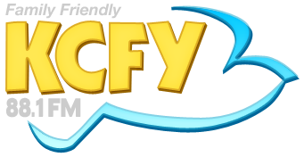
20th Annual KCFY
108 Hole Golf Marathon
Pledge Form

Golfer's Name:

Sponsor Name: Flat Amount: $
Sponsor Address: - OR -
City, State, Zip: Amount per hole:$
Sponsor Phone #: Paid: Yes or No
Email:

Sponsor Name: Flat Amount: $
Sponsor Address: - OR -
City, State, Zip: Amount per hole:$
Sponsor Phone #: Paid: Yes or No
Email:

Sponsor Name: Flat Amount: $
Sponsor Address: - OR -
City, State, Zip: Amount per hole:$
Sponsor Phone #: Paid: Yes or No
Email:

Sponsor Name: Flat Amount: $
Sponsor Address: - OR -
City, State, Zip: Amount per hole:$
Sponsor Phone #: Paid: Yes or No
Email:

GOLFER: WE MUST HAVE EMAIL ADDRESS IN ORDER TO INVOICE DONOR!!!

